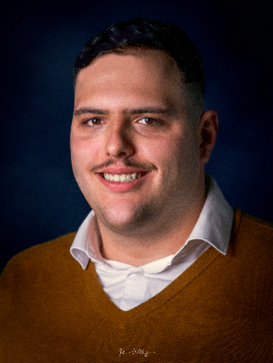

Laurent

CARLIZZI

# DETAILS

* February 27th 2000
* 24 years old
* Avenue de la Liberté 23

L-4601 Differdange

* [laurentcarlizzi@gmail.com](mailto:laurentcarlizzi@gmail.com)

*"Student in BTS Cybersecurity, with a varied background combining marketing, entrepreneurship, and teamwork. Motivated, adaptable, and passionate, I am determined to develop my skills in the field of cybersecurity."*

**WORKING EXPERIENCE**

**Worker, Quick, Kirchberg**

June 2023 – present

Kitchen management, customer service, cleaning

**Internship, Vautz Immo, Munsbach**

February 2023 - March 2023

Photo editing, administration

# COMPETENCES

Windows systems

Linux systems  
Cisco Networking

Office Pack

Project Management

|  |  |
| --- | --- |
|  | **EDUCATION** |
|  | **BTS Cybersecurity, Lycée Guillaume Kroll, Esch-sur-Alzette**  September 2024 – present    **BTS Business and Marketing, Ecole de Commerce et de Gestion (ECG), Luxembourg-Ville (2 years)**  September 2021 — February 2023 (not graduated)  **Bachelor in European Culture, German Studies, Université du Luxembourg, Esch-sur-Alzette (1 year)**  September 2020 — February 2021  **Secondary School degree in Trade and Business, Lycée technique de Lallange, Esch-sur-Alzette**  July 2020 |

# LANGUAGES

Luxembourgish  
German

English

French

Italian

**PROJECTS**

**Mini-Entreprise « Neon Empire »**

School Year 2018-2019

Stock management, business creation, sales

**Young Enterprise Project « Eco-Schachtel »**

School Year 2022-2023

Team management, business management, sustainable development

 **INTERESTS **

* Sports
* History
* Politics
* Films
* Video Games
* Collecting Cards

 **CERTIFICATIONS **

* Powerpoint
* Excel
* Word

|  |  |
| --- | --- |
|  | **OTHER ACTIVITES** |
|  | **Comitee Member, Association Italia Libera, Differdange**  February 2018 — présent  Event planning, administration, food production and service |
|  |  |